Chapter 18-[Collections of Sets](https://mfleck.cs.illinois.edu/building-blocks/version-1.3/sets-of-sets.pdf)

Tuesday, January 10, 2023

12:58 AM

***Collections of Sets:***

It's like sets of sets.

Collections of sets are denoted using weird (script) letters like



When a collection is the domain of a function, the function maps an entire subset to an output value.

For example, a collection of finite sets of integers can be the domain of a mean function, where the output of the function is the mean of whatever set inputted.





Note that an empty set can also be put into another set. (and it also counts as an element in a collection)

A ***Powerset*** is a collection that contains all subsets of a specific set.

For example, suppose that A = {1,2,3}, then



For a set with n elements, there **2n** elements in its powerset.

Note that **all** powersets contain the empty set.



Powersets often appear as the *co-domain* (aka output) of functions which need to return a set of values rather than just a single value.



The ***Partition*** of a set *A* are the non-overlapping subsets that include every original elements of *A.*

Recall an equivalence relation basically divides a set into different groups of numbers that are "equivalent."

This is related to partitioning!

For example, consider the below partition of integers:

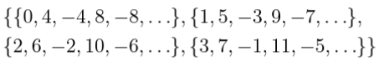

(It is just the definition of congruence mod 4)



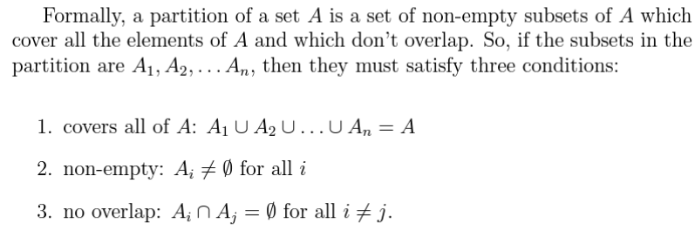

***Combinations:***



If we want to pick k objects from a list of n possible types, and we **allow duplicates** in the k objects, then the formula would be



Or the equivalent:

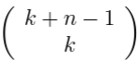

*(source: trust me bro)*

Some identities:

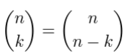

*(look at the denominator of the definition of n choose k and you should know why)*

*(look harder if you still don't know)*



Binomial Theorem:

